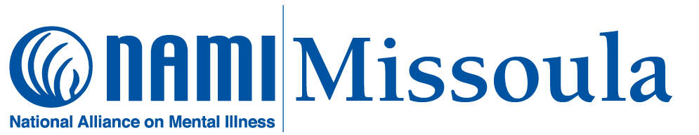
MAY 2 & 3: MISSOULA & BITTERROOT GIVES
This annual online fundraising event for local nonprofit organizations is sponsored by the Missoula Community Foundation. Please consider giving to NAMI Missoula on its “Missoula Gives” page: Give to NAMI Missoula | Missoula Gives All monies contributed to NAMI Missoula help support our free support groups, education classes, and community presentations.
================================
MAY 4: BRAIN INJURY CONFERENCE
This all-day event is sponsored by the Brain Injury Alliance of Montana. NAMI Missoula will have an information table at the event. Please stop by, say hello, and take home some NAMI literature (and NAMI swag!). For information: 2024 BIAMT Brain Injury Conference
=================================
MAY IS MENTAL HEALTH AWARENESS MONTH! For seventy-five years, May has been designated nationally as “Mental Health Awareness Month”; this year’s NAMI theme for May is “Take the Moment” (Mental Health Awareness Month | NAMI). Check our website (www.namimissoula.org) and our Facebook page ((20+) Facebook) for updates on “Mental Health Awareness Month” activities.
===================================
MAY 16: “DAY OF ACTION” for mental health! Awareness of mental illness is a necessary but not sufficient first step to bring about change; actions are required, and even small actions count. On May 16, we can all do something related to mental health: call a friend or family member, read an article about mental health issues, go for a leisurely walk, post something about mental health to your social media page(s), have a conversation about mental health with someone you haven’t talked about it with before, etc. Take the time to take the moment!
=====================================
MAY 29: “MENTAL HEALTH MATTERS: THE RIPPLE EFFECT” This NAMI Missoula Forum will be held at the Missoula Public Library from 6:15 p.m. to 7:45 p.m. It will be free and open to the public. The event will feature a panel of community leaders sharing their perspectives on the widespread community impacts of mental illness, making it a quality of life issue for everyone and not just for the families directly affected.
