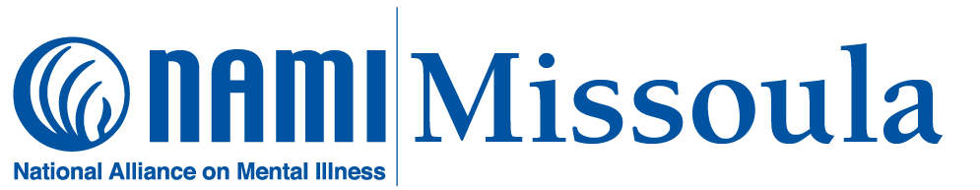
NAMI Missoula News (May 2024)
{May is “Mental Health Awareness Month.” A list of special May events is on page 3; our regular monthly schedule is on page 4. Updates and details can be found at: www.namimissoula.org}
April items:
- Sylvia Carollo and Brenda Allington have resigned from the NAMI Missoula Board of Directors; however, both will continue their involvement with us in other capacities.
- We met with the Director of Wellness at the University of Montana.
- We met again with members of the Strategic Alliance Peer Committee. We offered to adapt the NAMI Smarts “7 Steps to Telling Your Story” to help peers to advocate.
- NAMI Missoula members participated in the annual Crisis Intervention Team training academy. We continue to value our ongoing connection with CIT in Missoula.
- We completed our 8-week spring “Family-to-Family” education class.
- Our new Bitterroot “Family Support” group met for the first time on Thursday, April 11. The group meets in Stevensville on the second Thursday of each month; see our monthly schedule for details.
Coming up (details on page 3):
- May 2nd & 3rd: “Missoula & Bitterroot Gives”
- May 4th: “Montana Brain Injury Conference”
- May 16: “Day of Action for Mental Health”
- May 29: “Mental Health Matters: The Ripple Effect” at the Missoula Public Library
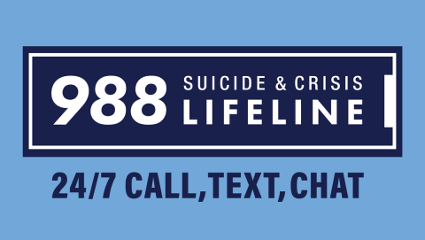
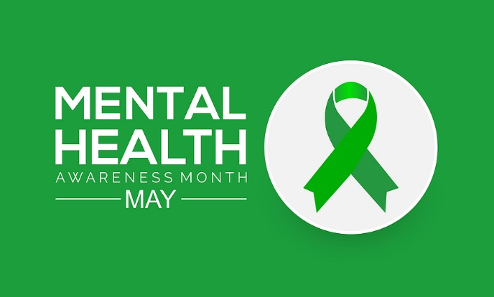
NAMI overview: Mental Health Awareness Month
May is Mental Health Awareness Month. Since its inception in 1949, Mental Health Awareness Month has been a cornerstone of addressing the challenges faced by millions of Americans living with mental health conditions. Throughout the month, NAMI actively participates in this national movement, dedicated to eradicating stigma, extending support, fostering public education and advocating for policies that prioritize the well-being of individuals and families affected by mental illness.
This year, NAMI is celebrating Mental Health Awareness Month with the Take the Moment campaign. We encourage you to join us in fostering open dialogues, cultivating empathy and understanding. We also urge you to share our resources to support individuals and families on their journey towards mental wellness. Through "Take the Moment," we shine a spotlight on NAMI's array of signature programs including: NAMI Basics, NAMI Family-to-Family, NAMI Family & Friends, NAMI Homefront, NAMI In Our Own Voice, NAMI Peer-to-Peer, NAMI Support Groups and our invaluable NAMI HelpLine, which is a free, nationwide peer-support service providing information, resource referrals and support to people living with a mental health condition, their family members and caregivers, mental health providers and the public.
This campaign also champions the importance of destigmatizing mental health by normalizing the practice of taking moments to prioritize mental health care without guilt or shame. Throughout May, we invite you to share with us on social media why or how you are taking moments to prioritize your mental health. Please use the hashtag #TakeAMentalHealthMoment in your posts.
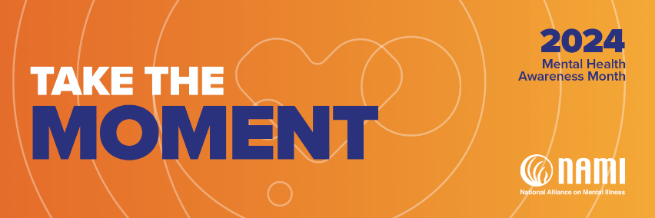
MAY 2 & 3: MISSOULA & BITTERROOT GIVES
This annual online fundraising event for local nonprofit organizations is sponsored by the Missoula Community Foundation. Please consider giving to NAMI Missoula on its “Missoula Gives” page: Give to NAMI Missoula | Missoula Gives All monies contributed to NAMI Missoula help support our free support groups, education classes, and community presentations.
================================
MAY 4: BRAIN INJURY CONFERENCE
This all-day event is sponsored by the Brain Injury Alliance of Montana. NAMI Missoula will have an information table at the event. Please stop by, say hello, and take home some NAMI literature (and NAMI swag!). For information: 2024 BIAMT Brain Injury Conference
=================================
MAY IS MENTAL HEALTH AWARENESS MONTH! For seventy-five years, May has been designated nationally as “Mental Health Awareness Month”; this year’s NAMI theme for May is “Take the Moment” (Mental Health Awareness Month | NAMI). Check our website (www.namimissoula.org) and our Facebook page ((20+) Facebook) for updates on “Mental Health Awareness Month” activities.
===================================
MAY 16: “DAY OF ACTION” for mental health! Awareness of mental illness is a necessary but not sufficient first step to bring about change; actions are required, and even small actions count. On May 16, we can all do something related to mental health: call a friend or family member, read an article about mental health issues, go for a leisurely walk, post something about mental health to your social media page(s), have a conversation about mental health with someone you haven’t talked about it with before, etc. Take the moment to spread the word!
=====================================
MAY 29: “MENTAL HEALTH MATTERS: THE RIPPLE EFFECT” This NAMI Missoula Forum will be held at the Missoula Public Library from 6:15 p.m. to 7:45 p.m. It will be free and open to the public. The event will feature a panel of community leaders sharing their perspectives on the widespread community impacts of mental illness, making it a quality of life issue for everyone and not just for the families directly affected.
For more information: namimissoula@gmail.com / 406-880-1013
Monthly Schedule (May 2024)
Wednesday, May 1 (1:00—2:30 pm): NAMI Connection is a free, confidential, peer-led support group for adults living with mental illness. The group meets in person every Wednesday at 202 Brooks, Room 208. No registration is required; newcomers are always welcome; you do not need to be a NAMI member to attend. A Zoom option is also available; email us at namimissoula@gmail.com for the Zoom link.
Wednesday, May 8 (1:00—2:30 pm): NAMI Connection, 202 Brooks
Thursday, May 9 (6:30—8:00 pm): NAMI Family Support in the Bitterroot is a free, confidential, peer-led support group for adult relatives, friends, and caregivers of individuals with mental illness. The group meets in person on the second Thursday of each month, from 6:30 to 8:00 p.m., at 203 Main Street in Stevensville. No registration is required; newcomers are always welcome; you do not need to be a NAMI member to attend. You can direct questions to namimissoula@gmail.com or call 406-880-1013.
Wednesday, May 15 (1:00—2:30 pm): NAMI Connection, 202 Brooks
Thursday, May 16 (6:30—8:00 pm): NAMI Family Support in Missoula is a free, confidential, peer-led support group for adult relatives, friends, and caregivers of individuals with mental illness. The group meets in person on the third Thursday of each month, from 6:30 to 8:00 p.m., at 202 Brooks (Room 208) in Missoula. No registration is required; newcomers are always welcome; you do not need to be a NAMI member to attend.
Wednesday, May 22 (1:00—2:30 pm): NAMI Connection, 202 Brooks
Wednesday, May 29 (1:00—2:30 pm): NAMI Connection, 202 Brooks
====================================================
Don’t forget: May is Mental Health Awareness Month! You can donate to NAMI Missoula on May 2nd and May 3rd through the “Missoula & Bitterroot Gives” online fundraiser: Give to NAMI Missoula | Missoula Gives. May 16 is a “Day of Action for Mental Health,” and on May 29 there will be a panel discussion at the Missoula Public Library on “Mental Health Matters: The Ripple Effect.” The event is organized and hosted by NAMI Missoula; panelists will be community leaders sharing their perspectives on the widespread impacts of mental illness in Missoula.
