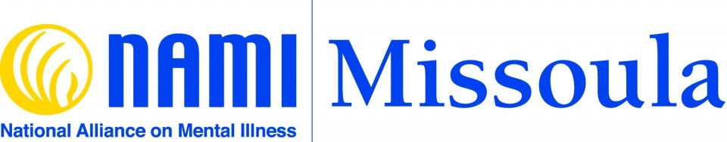
Who We Are
NAMI Missoula is the local affiliate of the National Alliance on Mental Illness, one of over six hundred such affiliates around the country. NAMI is the nation’s largest grassroots organization devoted to mental health issues; it has been in existence since 1983.
NAMI Missoula was formed in 1997, having begun a decade earlier as an independent local advocacy group called “A New Beginning”. Founding members included Dorothy Salmonson, Jean Sharkey, Berneice Patterson, Martha Onishuk. Past officers included Mary Morman, Jan Berens, Karen Ward, Bev Young, and more. We are grateful for their invaluable contributions to NAMI Missoula and to the community.
NAMI Missoula is recognized by the IRS as a not-for-profit organization (EIN#81-0405416) and as a registered charity in the state of Montana. We report both to the NAMI Montana state office in Helena and to the NAMI national office in Arlington, Virginia.
NAMI Missoula’s Board of Directors (elected by the members) is responsible for overseeing all NAMI Missoula programs, events, and finances; an Executive Committee provides leadership and direction. The NAMI Missoula board meets monthly; minutes of the board meetings are on file in our office and can be accessed there by members of NAMI Missoula and by the public.
As of April 15, 2024, the NAMI Missoula Board consists of:
Suzin Kratina (President); Tami Burlingame (Treasurer); Suzanne Sterrett (Recording Secretary); Zan Bockes; Marcia Dias; Patricia Kouris; Mark Medvetz
Diversity, Equity, and Inclusion
At NAMI Missoula, we believe a diverse, inclusive, and equitable organization is one where all employees, volunteers, and members — regardless of gender, race, gender identity, ethnicity, national origin, age, sexual orientation, education, disability, veteran status, or other marker of identity or dimension of diversity — feel valued and respected. This same belief informs our groups, programs, events, and advocacy.
