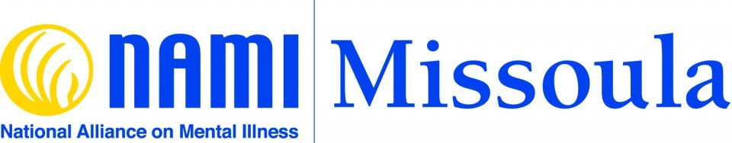

Touching hearts. Healing minds. Connecting people. Offering hope. Changing lives.
What We Do
Support / Educate / Advocate / Lead / Listen / Care / Understand
Support: Our “NAMI Connection” group provides ongoing support for adults living with mental illness. Our “NAMI Family Support” group provides support for adult relatives, friends, and caregivers of individuals with mental illness. NAMI support groups are always free, confidential, and peer-led. Registration for these groups is not required; you do not need to be a member of NAMI to attend.
Educate: “NAMI Peer-to-Peer” is an eight-session course for adults living with mental illness. “NAMI Family-to-Family” is an eight-session course for adult relatives, friends, and caregivers of individuals with mental illness. NAMI “signature” programs are free, confidential, and peer-led. You do not need to be a member of NAMI to attend. Class size for these courses is limited; registration is required.
Advocate: NAMI Missoula works with numerous agencies and organizations in the community to make sure our voice is heard on behalf of the people we represent. In addition, our “NAMI In Our Own Voice” presentations take the NAMI message into public venues—schools, faith communities, civic groups, and more. Our annual “NAMI Walk” promotes awareness and combats stigma against those who live with mental illness.
You Are Not Alone:
“You Are Not Alone” is the NAMI Missoula community resource booklet; it includes links to, and information about, mental health resources, legal resources, housing resources, and more. “You Are Not Alone” is updated periodically, and we distribute the booklet for free throughout the community. You can download a copy of “You Are Not Alone” here: You Are Not Alone – Spring 2022 updated version.pdf

