Quick List: Essential Phone Numbers
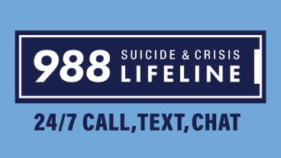

(Montana numbers require 1-406)
988: Crisis Prevention Line (or text MT to 741 741)
911: Emergencies
211: Missoula County Services and Information Line
All Nations Health Center: 829-9515
Community Medical Center: (406) 728-4100

Missoula Aging and Disability Services: 728-7682
Missoula County Sheriff: 258-4810
Missoula County Suicide Prevention Office: (406) 258-3881

Missoula Crisis Response Team: (406) 532-9710

Missoula Police (non-emergency): 552-6300
Montana Division of Addictive and Mental Disorders (AMDD): 444-3964
Montana Warm Line: 1-877-688-3377 (no 1-406 prefix needed)
NAMI Missoula: 880-1013
NAMI Montana: 406-443-7871
NAMI National Helpline: 1-800-950-6264 (no 1-406 prefix needed)
Partnership Health Center: 258-4789
Poverello Center: 728-1809
Providence Center: 327-3200
Providence “Urgent Care” clinic: (406) 327-3034
Salvation Army: 549-0710
St. Patrick Hospital: 543-7271
Summit Independent Living Center: 728-1630
Tamarack Grief Resource Center: 541-8472
Three Rivers Mental Health: 830-3294
UM Curry Counseling Center: 243-2122
Warm Springs State Hospital: 693-7000
Western Montana Mental Health Center: 532-9700
Winds of Change Mental Health Center: 541-4673
