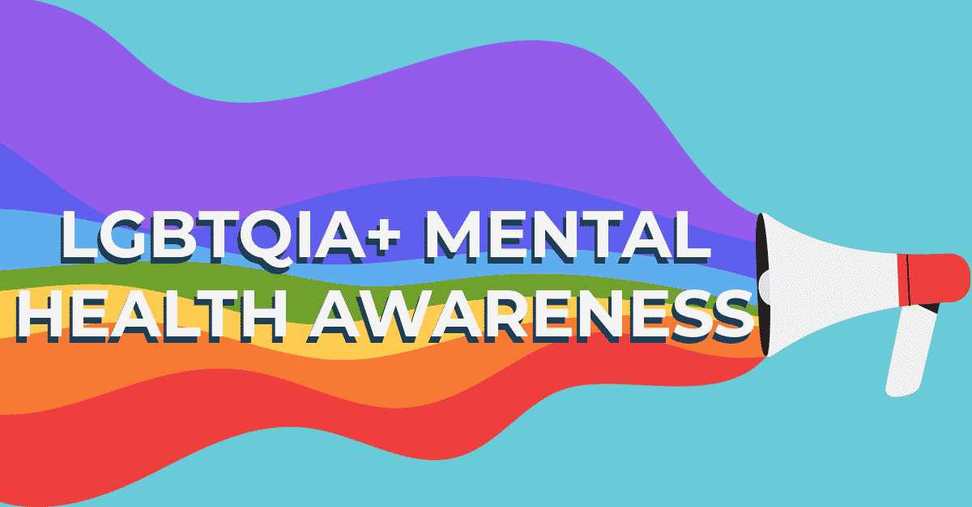

A Guide to the Mental Health Challenges of the LGBTQIA+ Community

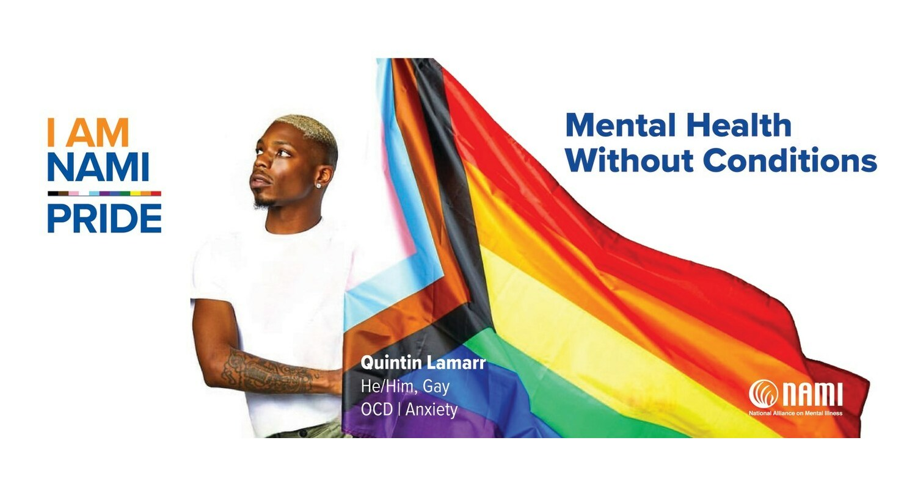
June 2023: This guide has been compiled by NAMI Missoula from materials on the NAMI national website (www.nami.org). We cannot guarantee the accuracy of information provided, nor do we endorse or recommend any of the linked resources. NAMI Missoula fully supports the LGBTQIA+ community and the right of LGBTQIA+ individuals to acceptance, recognition, and respect.
The Lesbian, Gay, Bisexual, Transgender, Queer, Questioning Plus (LGBTQIA+*) community represents a diverse range of identities and expressions of gender and sexual orientation. In addition to these identities, members of the community are diverse in terms of race, religion, ethnicity, nationality and socioeconomic class. This intersectionality — the combined and overlapping aspects of a person’s identity — brings diversity of thought, perspective, understanding and experience. This complexity is important to understand as a unique and valuable aspect of the LGBTQIA+ community that can result in a strong sense of pride and resiliency.
While belonging to the LGBTQIA+ community can be a source of strength, it also brings unique challenges. For those who identify as LGBTQIA+, it’s important to recognize how your experience of sexual orientation and gender identity relates to your mental health.
Although the full range of LGBTQIA+ identities are not commonly included in large-scale studies of mental health, there is strong evidence from recent research that members of this community are at a higher risk for experiencing mental health conditions — especially depression and anxiety disorders. LGBTQIA+ adults are more than twice as likely as heterosexual adults to experience a mental health condition. Transgender individuals are nearly four times as likely as cisgender individuals (people whose gender identity corresponds with their birth sex) individuals to experience a mental health condition.
LGBTQIA+ youth also experience greater risk for mental health conditions and suicidality. LGBTQIA+ youth are more than twice as likely to report persistent feelings of sadness or hopelessness than their heterosexual peers. Transgender youth face further disparities as they are twice as likely to experience depressive symptoms, seriously consider suicide, and attempt suicide compared to cisgender lesbian, gay, bisexual, queer and questioning youth.

For many LGBTQIA+ people, socioeconomic and cultural conditions negatively impact mental health conditions. Many in the LGBTQIA+ community face discrimination, prejudice, denial of civil and human rights, harassment and family rejection, which can lead to new or worsened symptoms, particularly for those with intersecting racial or socioeconomic identities.

Important Risk Factors of LGBTQIA+ Mental Health
Coming Out
Positive changes in societal acceptance of LGBTQIA+ people act as a protective factor for mental health. However, this shift in acceptance has meant that many LGBTQIA+ youth “come out” or share their sexual orientation or gender identity at younger developmental ages, which can impact their social experiences and relationships. This can have negative mental health impacts, particularly for youth who are not in supportive environments.

Rejection
For many in the LGBTQIA+ community, coming out can be a difficult or even traumatic experience. It can be difficult to cope with rejection of something as personal as one’s identity from family or close friends, within the workplace, or in a faith community.
According to a 2013 survey, 40% of LGBTQIA+ adults have experienced rejection from a family member or a close friend. A 2019 school climate survey showed that 86% of LGBTQIA+ youth reported being harassed or assaulted at school, which can significantly impact their mental health. And a 2022 report from The Trevor Project found that just 37% of LGBTQIA+ youth identified their home as an LGBTQIA+-affirming space.

Trauma
Homophobia, biphobia, transphobia, bullying and feeling identity-based shame is often traumatic for people.

The LGBTQIA+ community faces many forms of discrimination, including: labeling, stereotyping, denial of opportunities or access, and verbal, mental and physical abuse. They are one of the most targeted communities by perpetrators of hate crimes in the country. Such discrimination can contribute to a significantly heightened risk for PTSD among individuals in the LGBTQIA+ community compared to those who identity as heterosexual and cisgender.

Substance Use
Substance misuse or overuse, which may be used as a coping mechanism or method of self-medication, is a significant concern for members of this community. LGBTQIA+ adults are nearly twice as likely as heterosexual adults to experience a substance use disorder. Transgender individuals are almost four times as likely as cisgender individuals to experience a substance use disorder. Illicit drug use is significantly higher in high school-aged youth who identify as LGB or are unsure of their identity, compared to their heterosexual peers.

Homelessness
It is estimated that LGBTQIA+ youth and young adults have a 120% higher risk of experiencing homelessness — often the result of family rejection or discrimination based on gender identity or sexual orientation. This risk is especially high among Black and Native American/Alaska Native LGBTQIA+ youth. Many members of the LGBTQIA+ community face the added challenge of finding homeless shelters that will accept them, and experience elevated rates of harassment and abuse in these spaces.

Suicide
Many people in this community struggle in silence — and face worse health outcomes as a result.
- The LGBTQIA+ population is at a higher risk than the heterosexual, cisgender population for suicidal thoughts and suicide attempts.
- High school students who identify as lesbian, gay or bisexual are more than four times as likely to have attempted suicide compared to their heterosexual peers.
- 40% of transgender adults have attempted suicide in their lifetime, compared to less than 5% of the general U.S. population.

Inadequate Mental Health Care
The approach to sexual orientation and gender identity in mental health care often groups together anyone in the LGBTQIA+ community, when these communities are considered at all. This method can be problematic as each sub-community faces unique challenges, rates of mental illness and experiences.

The LGBTQIA+ community encompasses a wide range of individuals with separate and overlapping challenges regarding their mental health. Other identity factors including race and economic status can affect the quality of care they receive or their ability to access care.
Additionally, members of this community may face harassment or a lack of cultural competency from potential providers. These experiences can lead to a fear of disclosing sexual orientation and/or gender identity due to potential discrimination or provider bias.
Confronting these barriers and mental health symptoms with an LGBTQIA+-inclusive mental health provider can lead to better outcomes, and ultimately recovery.

How to Find the Right Mental Health Professional
There are important considerations when seeking LGBTQI-competent care. Here are a few steps to find a professional.
Step 1: Think About What You’re Looking For

While considering the type of mental health professional you are looking for, it is important to consider the following:
- If you want a provider who shares specific parts of their identity with you, you may be able to find out if your provider is LGBTQIA+ by reading their profiles or websites.
- It may be easier to find a provider that has a baseline competency in LGBTQIA+ issues, rather than one who specializes in LGBTQIA+ care. If your mental health conditions are not rooted in sexual orientation and/or gender identity, it may not be necessary for the provider to be specialized in LGBTQIA+ issues.
- If you are transgender and are seeking a mental health professional to write a letter of support for gender affirming medical care or for legal documentation change, you should seek a provider who understands the insurance or legal requirements of support letters.

Step 2: Gather Referrals

Many websites that provide mental health professional directory searches, including insurance company websites, have filters that allow you to show only mental health providers who have a specialty or competency in working with LGBTQIA+ patients. Many insurance companies also have information numbers, and they can help find you providers that are in your area, accept your insurance and list LGBTQIA+ competency in their profile.
These directories, however, are not the only way to find LGBTQIA+ competent providers. Many LGBTQIA+ organizations and community groups provide directories that have been vetted by other LGBTQIA+ people. You may want to check with:
- Local LGBTQIA+ community centers
- Local LGBTQIA+ health centers
- LGBTQIA+ community groups such as equality groups, health collectives, social organizations, support groups
- Affirming places of worship

Step 3: Make the Call

Some people find it difficult to make an initial call to a mental health provider. Transgender people in particular may feel uncomfortable talking on the phone due to concerns about being misgendered due to their natural voice range. If you find you’re reluctant to call, ask a friend or family member to call for you.

When making the initial call, you may want to ask the provider then if they have previous experience with LGBTQIA+ patients or if they are comfortable working with LGBTQIA+ patients. You can wait to ask this during the first appointment, but you may save time and energy by asking from the start.
Step 4: Ask Questions

Providers expect and welcome questions from their patients or clients, since this helps them better understand what is important in their treatment. In your first visit with a mental health provider, be forthright about the fact that you are looking for an LGBTQIA+ competent provider. You should not feel like you need to educate providers about the basic concepts of LGBTQIA+ identities. To prevent that, consider asking the following questions:
- My identity is ______. What experience do you have working with people with that identity?
- What experience do you have with the LGBTQIA+ community?
- Do you have any specific training or certifications that relate to working with LGBTQIA+ clients?

Additionally, to avoid selecting a practitioner that uses the discredited and harmful practice of conversion or reparative therapy — aimed at changing a person’s sexual orientation or gender identity — you may also want to ask, “Do you provide conversion therapy or reparative therapy?” and follow up by asking how they feel about that specific practice to make sure you are not selecting a provider that advocates for this type of treatment.
Step 5: Build a Relationship

It may take several calls to find the right provider for you. If the provider does not have the knowledge or experience that you are looking for, you can move on to the next provider and keep searching.
Remember, you are seeking a person that is going to help you improve your mental health. By stating your needs and asking the right questions, you can find someone who can mindfully address your identity throughout the duration of your treatment.
*This list of initials is not an exhaustive list of identities included in this community and related groups. We want to be explicit in our support of all people who identify as community members, whether their identity is commonly acknowledged or not. This includes those who are non-binary, two-spirit, third-gender, asexual and more.

Resources
Please note: The resources included here are not endorsed by NAMI. NAMI is not responsible for the content of or service provided by any of these resources.

In Missoula:

The Center - Western Montana's LGBTQ+ Community Center - Missoula (gaymontana.org)

LGBTQAI Resources in MT | MTFC Live (mtfamilycenter.org)

LGBTQ+ (umt.edu)

Montana Pride

Nationwide:

CenterLink LGBT Community Center Member Directory

The American Psychological Association (APA)
Provides educational and support resources on a range of LGBTQ topics.

The Association of Gay and Lesbian Psychiatrists
Offers many resources for LGBT individuals experiencing mental health conditions and psychiatric professionals with LGBT clients.

The Gay and Lesbian Medical Association's Provider Directory
A search tool that can locate a LGBTQ-inclusive health care provider.

The LGBT National Help Center
Offers confidential peer support connections for LGBT youth, adults and seniors, including phone, text and online chat.

The National Center for Transgender Equality
Offers resources for transgender individuals, including information on the right to access health care.

The Trevor Project
A support network for LGBTQ youth providing crisis intervention and suicide prevention, including a 24-hour text line (text “START” to 678678).

SAGE National LGBT Elder Hotline

Society for Sexual, Affectional, Intersex, and Gender Expansive Identities (SAIGE)
Delivers educational and support resources for LGBTQ individuals, as well as promotes competency on LGBTQ issues for counseling professionals.

Trans Lifeline

Depression Looks Like Me
Depression Looks Like Me is a program – sponsored by the Johnson & Johnson Company and supported by an alliance of other partners – that aims to educate and empower LGBTQIA+ people with depression.

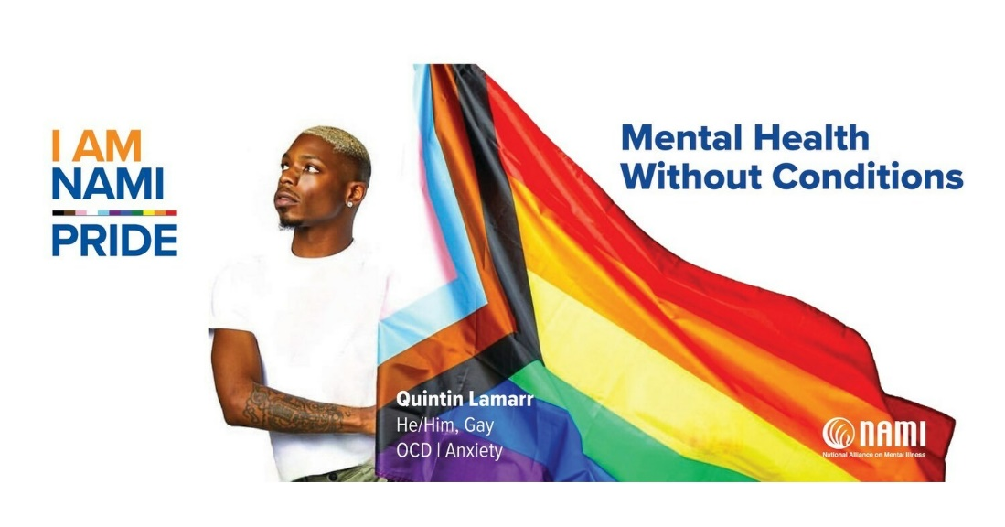
202 Brooks Street, Room 210 / Missoula MT 59801
PO Box 5413, Missoula MT 59806 / 406-880-1013
namimissoula@gmail.com / www.namimissoula.org
www.facebook.com/NAMIMissoula
