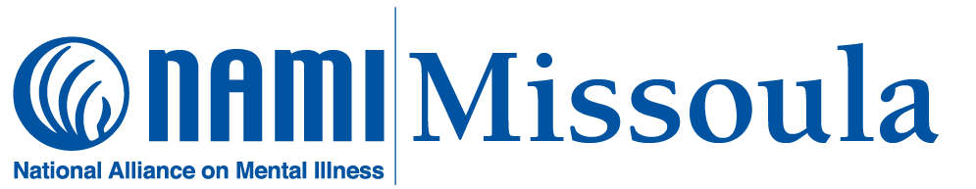

April 2024 Schedule
Wednesday, April 3: NAMI Connection support group. This is a weekly group for adults living with mental illness. It is free, confidential, and peer-led; no registration is necessary, newcomers are always welcomed. The group meets every Wednesday (1:00—2:30) at 202 Brooks, Rm. 208. A Zoom option is available: https://us02web.zoom.us/j/87807649737
Wednesday, April 3: NAMI Family-to-Family education class (Week Five). Registration for this class is closed.
Wednesday, April 10: NAMI Connection support group
Family-to-Family (Week Six)
Wednesday, April 17: NAMI Connection support group
Family-to-Family (Week Seven)
Thursday, April 18: NAMI “Family Support” group. This monthly group is for adult relatives, friends, and caregivers of individuals with mental illness. It is free, confidential, and peer-led; no registration is required, and newcomers are always welcomed. The group meets on the third Thursday evening of each month (6:30—8:00 pm) at 202 Brooks, Room 208.
Wednesday, April 24: NAMI Connection support group
Family-to-Family (Week Eight)
--------------------------------------------------------------------------------------------
YOU DO NOT NEED TO BE A NAMI MEMBER TO ATTEND NAMI GROUPS!
Schedule is subject to change. For up-to-date information: 406-880-1013; namimissoula@gmail.com; www.namimissoula.org

