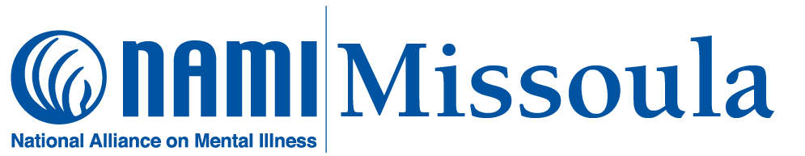
NAMI Missoula News (April 3, 2024)
{Our April schedule is on page 4)
What’s new with NAMI Missoula?
- We met with students from the UM Mental Health Allies, the UM Psychology Club, and the UM Neuroscience Club. We’re looking to build stronger relationships with the campus community and to be more active in working with student groups.
- Our spring “Family-to-Family” class has been meeting since March 6 in a space provided by Western Montana Mental Health Center. The group will conclude on April 24.
- We met with Stephanie Rosier (new coordinator for the Missoula Strategic Alliance Peer Committee) to discuss how NAMI Missoula can support and/or work with the Peer Committee.
- On March 27, we participated in the “Project Community Connect” event at the Missoula Public Library. The event was an opportunity to share information about NAMI programs and services with individuals in the community who might be in need of them. Our thanks to our volunteers—Brenda, Megan, and Chatelle—and, of course, to the staff at MPL for doing such a great job organizing and hosting the event.
What’s coming up?
- Our April board meeting will be on Monday, April 8 (10:00—noon) at 202 Brooks, Room 210. All NAMI Missoula members are invited; members of the public may also attend.
- April is “Minority Health Month”. It is also “National Volunteer Month”.
- May will be “Mental Health Awareness Month,” and we will be busy! Keep an eye on our website and Facebook page for information, articles, and resources.
- On May 2 & 3, we will be participating in the annual “Missoula Gives” online fundraising event for local nonprofit organizations.
- On May 4, we will have a table at the “Brain Injury Conference” sponsored by the Brain Injury Alliance of Montana (BIAMT). We will provide information about our programs and activities, and NAMI Missoula volunteers will be present to answer questions.
- May 16 is designated as a “Day of Action for Mental Health”. We hope to have an event scheduled; check our website and our Facebook page for information.
- On May 29, we will present “Mental Health Matters: The Ripple Effect” at the Missoula Public Library. Again, check our website and Facebook page for details.
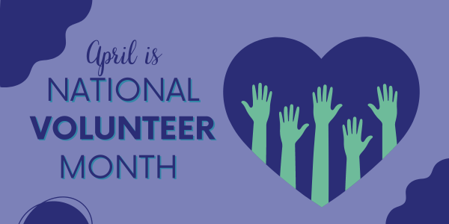

National Volunteer Month is an annual celebration dedicated to honoring volunteering efforts around the world — recognizing and becoming people who selflessly devote their time, skills, and energy to support various causes. From aiding the less fortunate to preserving the environment, volunteers play an indispensable role in shaping a brighter future for all.

For the past thirty years, NAMI Missoula has depended on volunteers—including members of our Board of Directors—to achieve its mission. Our volunteers enable us to support, educate, and advocate for individuals and families in our community who are challenged by mental illness. More than that, it is our volunteers who, through their work with NAMI, “Touch hearts, Heal minds, Connect people, and Change lives.”

So, on behalf of NAMI Missoula: Thank You to all of our volunteers!

5 Great Ideas to Celebrate During National Volunteer Month (galaxydigital.com)

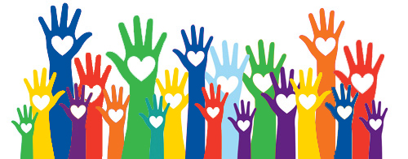

VOLUNTEER WITH NAMI MISSOULA!

Contact us: 406-880-1013 / namimissoula@gmail.com

Follow us: www.namimissoula.org

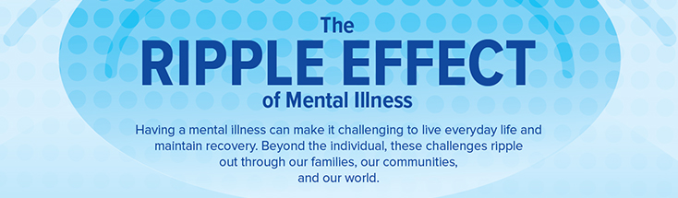
The Ripple Effect
The social impact of mental illness goes well beyond the individuals and families directly affected. Especially when undiagnosed or untreated, mental illnesses are a contributing factor to a wide range of problems: poor physical health, substance abuse, unemployment, school drop-out rate, crime, prison overcrowding, homelessness, domestic conflict, family instability, financial stress, rising disability rates, suicide rates, etc.
Mental illness, in other words, isn’t just “something” that happens to “someone”; it happens to all of us, and it affects the quality of life in our communities. The financial cost can be measured in lost earnings, government subsidies, and the funding of the many agencies and programs, public and private, required to deal with mental illness and its ripples. More importantly, the cost in human terms and in lost human potential is nothing short of staggering.
NAMI Missoula believes that the issue of mental health cannot be effectively addressed within the mental health system alone; it must be a community priority. Models exist for the creation of “mental-health friendly” cities, based on criteria ranging from mental health treatment resources to the availability of urban green space, transportation, public restrooms, homeless shelters, and more. There needs to be an emphasis on young people: early diagnosis, treatment, and the development of coping skills are essential to mitigating the adverse effects of mental illness. We need ongoing community conversations, neighborhood outreach, buy-in from civic leadership, and coordinated efforts to make Missoula more mental-health friendly.
PLEASE JOIN US ON WEDNESDAY, MAY 29 (6:15—7:45 PM) AT THE MISSOULA PUBLIC LIBRARY FOR OUR MENTAL HEALTH MONTH NAMI FORUM:
“MENTAL HEALTH MATTERS: THE RIPPLE EFFECT”
THIS PANEL DISCUSSION WILL BE FREE AND OPEN TO THE PUBLIC
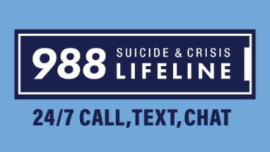
April 2024 Schedule
Wednesday, April 3: NAMI Connection support group. This is a weekly group for adults living with mental illness. It is free, confidential, and peer-led; no registration is necessary, newcomers are always welcomed. The group meets every Wednesday (1:00—2:30) at 202 Brooks, Rm. 208. A Zoom option is available: https://us02web.zoom.us/j/87807649737
Wednesday, April 3: NAMI Family-to-Family education class (Week Five). Registration for this class is closed.
Wednesday, April 10: NAMI Connection support group
Family-to-Family (Week Six)
Wednesday, April 17: NAMI Connection support group
Family-to-Family (Week Seven)
Thursday, April 18: NAMI “Family Support” group. This monthly group is for adult relatives, friends, and caregivers of individuals with mental illness. It is free, confidential, and peer-led; no registration is required, and newcomers are always welcomed. The group meets on the third Thursday evening of each month (6:30—8:00 pm) at 202 Brooks, Room 208.
Wednesday, April 24: NAMI Connection support group
Family-to-Family (Week Eight)
--------------------------------------------------------------------------------------------
YOU DO NOT NEED TO BE A NAMI MEMBER TO ATTEND OUR GROUPS!
Schedule is subject to change. For up-to-date information: 406-880-1013; namimissoula@gmail.com; www.namimissoula.org

